**Use these to poll your classroom and graph the results!**

I call the glowing beetles with flash patterns:

Fireflies

Lightning Bugs

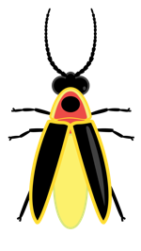I call the glowing beetles with flash patterns:

Fireflies

Lightning Bugs

I call the glowing beetles with flash patterns:

Fireflies

Lightning Bugs

I call the glowing beetles with flash patterns:

Fireflies

Lightning Bugs